GDB Investigation
Investigation of ShipmentItem Construction
The first meaningful GDB investigation focused on the construction of a ShipmentItem.
A breakpoint was placed inside:
ShipmentItem::ShipmentItem
At the beginning of the constructor, GDB showed the following important values:
this = 0x55555557a8b0
id = "ITEM01"
weight = 3.5
destination = "Pretoria"
baseCost = 150
priorityFlag = false
delivery = 0x0

At this point, the delivery pointer was still null. Attempting to inspect the object through this pointer produced:
Cannot access memory at address 0x0

This was not considered a bug. The debugger was stopped during the construction process, before the member initializer had created the Delivery object.
After stepping out of the constructor and returning to main, the object was fully initialized:
item1 = 0x55555557a8b0
item1->delivery = 0x55555557a920

Inspection of the Delivery object showed:
currentState = 0x55555557a4c0
location = "Depot"
history = {"Created"}

The investigation therefore confirmed that a ShipmentItem dynamically creates and owns a Delivery, and that the Delivery initially starts in the Created state.
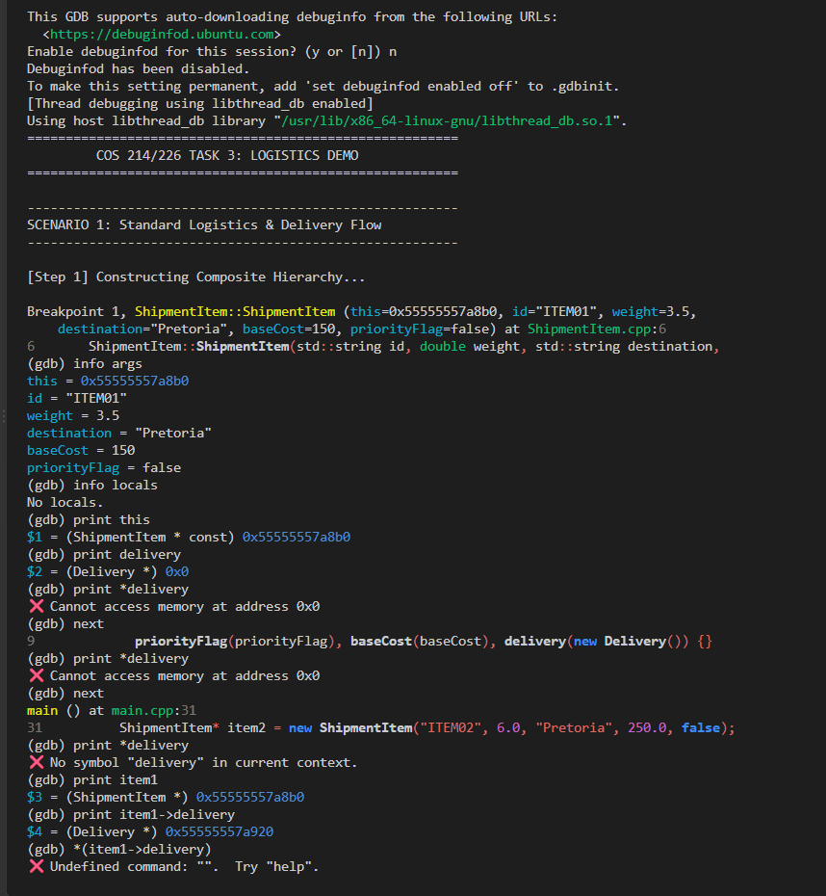
Investigation of the State Pattern
The second GDB investigation focused on the Delivery::setState() method.
The application begins a delivery in the Created state. Valid operations then transition the delivery through:
Created -> PickedUp -> InTransit -> Delivered
A breakpoint was placed in:
Delivery::setState
During the first transition, GDB showed:
this = 0x55555557a920
state = 0x55555557abe0
currentState = 0x55555557a4c0
currentState->getName() = "Created"
state->getName() = "PickedUp"
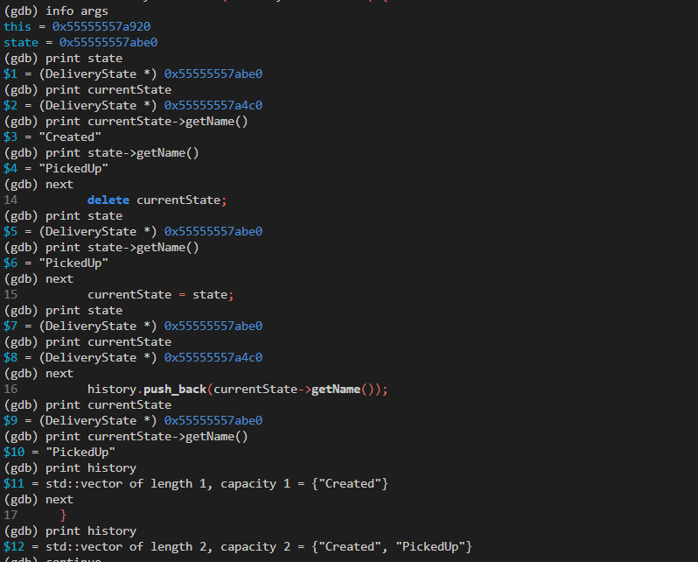

The method then deletes the previous state:
delete currentState;
and replaces it with the new state:
currentState = state;
The delivery history is subsequently updated.
After the transition, GDB showed:
currentState = 0x55555557abe0
currentState->getName() = "PickedUp"
history = {"Created", "PickedUp"}
The second transition changed the state from:
PickedUp -> InTransit

and the third transition changed it from:
InTransit -> Delivered
The final history was:
{"Created", "PickedUp", "InTransit", "Delivered"}
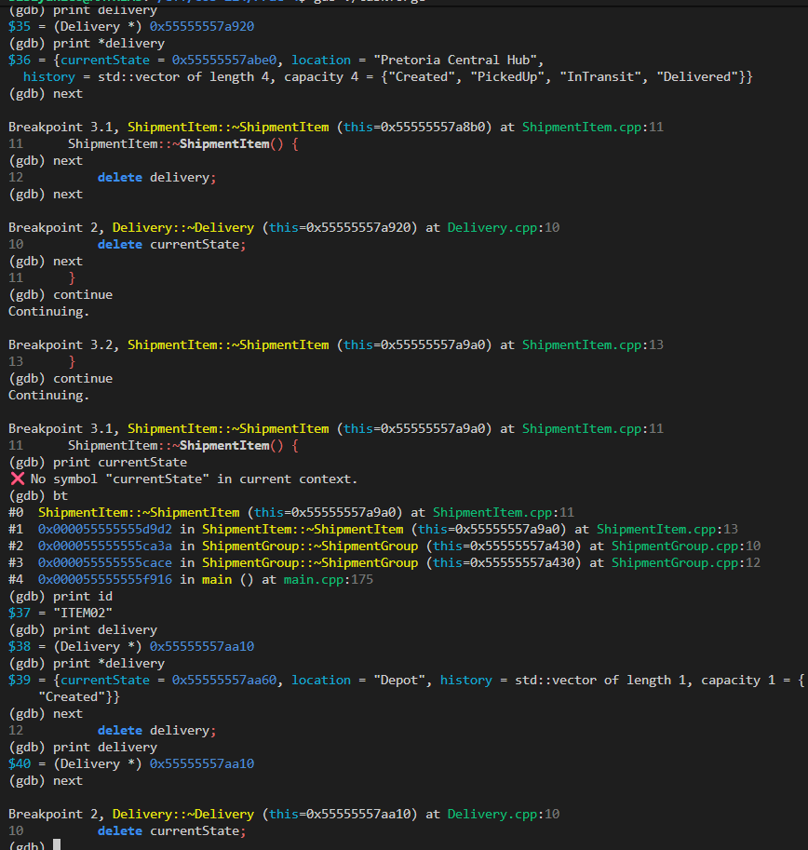

This provided runtime evidence that the State pattern was functioning correctly.

GDB observation
During some GDB stepping operations, an expression temporarily produced:
Cannot access memory at address 0x55500002f9a2
This occurred around the source-level boundary immediately after a state pointer was deleted or replaced. After another next command, the pointer was valid and the expected state could be inspected.
This was determined to be a debugger stepping/source-line timing artefact, rather than a program defect. The program subsequently completed the state transition correctly.

GDB Investigation of Memory Ownership and Destruction
A third investigation was performed to verify the application's ownership relationships during cleanup.
Breakpoints were placed on the following destructors:
Delivery::~Delivery
ShipmentItem::~ShipmentItem
ShipmentGroup::~ShipmentGroup
ShipmentDecorator::~ShipmentDecorator

The first important observation occurred when the root ShipmentGroup was destroyed.
GDB showed:
this = 0x55555557a430
id = "G01"
children.size() = 3

The children were:
0x55555557a8b0
0x55555557a9a0
0x55555557a800

The first child was inspected:
children[0] = 0x55555557a8b0
children[0]->getId() = "ITEM01"

GDB's object inspection confirmed that the object was a ShipmentItem.
The group destructor contains:
for (ShipmentComponent* child : children) {
delete child;
}

Therefore, when the group is destroyed, it is responsible for destroying the components that it owns.
The next breakpoint entered:
ShipmentItem::~ShipmentItem

for ITEM01.
GDB showed:
id = "ITEM01"
delivery = 0x55555557a920

The Delivery object contained:
currentState = 0x55555557abe0
location = "Pretoria Central Hub"
history = {"Created", "PickedUp", "InTransit", "Delivered"}

The ShipmentItem destructor then executed:
delete delivery;

This caused execution to enter:
Delivery::~Delivery

The Delivery destructor subsequently deletes its current state.
The observed ownership chain was therefore:
ShipmentGroup
|
+-- ShipmentItem
|
+-- Delivery
|
+-- DeliveryState

This confirmed that the application's dynamic objects form a cascading ownership hierarchy.
The same behaviour was observed for the second shipment item, ITEM02, whose Delivery object was also destroyed through its ShipmentItem destructor.
The investigation also confirmed that ShipmentComponent has a virtual destructor:
virtual ~ShipmentComponent();

This is important because derived objects such as ShipmentItem and ShipmentGroup are deleted through ShipmentComponent* pointers. The virtual destructor ensures that the appropriate derived destructor is called.

Genuine Bug Investigation

Description of the Bug
A genuine functional bug was discovered in the implementation of: PriorityIterator
The purpose of the priority iterator is to traverse the shipment structure and return only urgent shipment items.
The application uses a Composite structure in which a ShipmentGroup can contain other groups and shipment items.
The full iterator intentionally includes both groups and items.
The original PriorityIterator::advanceToNextUrgent() implementation was:
void PriorityIterator::advanceToNextUrgent() {
nextUrgent = nullptr;

while (internalIterator->hasNext()) {
ShipmentComponent* candidate = internalIterator->next();

if (candidate->isUrgent()) {
nextUrgent = candidate;
break;
}
}
}

The problem was that ShipmentGroup::isUrgent() returns true when any urgent item exists somewhere inside the group.
Therefore, a group containing an urgent item was itself reported as urgent by the iterator.
The priority iterator consequently returned groups as well as urgent shipment items.

Observable Symptoms
The incorrect urgent manifest contained:
=== URGENT MANIFEST ===
[Group] HUB-01 (Gauteng Distribution Hub) -> Midrand | weight=17 cost=350
[Group] DEP-A (Pretoria Local Depot) -> Pretoria | weight=17 cost=350
- Item PKG-101 (Pretoria, 5kg, R200, state=Created, URGENT)
- Item PKG-102 (Johannesburg, 12kg, R150, state=Created)
[Group] DEP-B (Johannesburg Express Hub) -> Johannesburg | weight=0 cost=0
[Group] DEP-A (Pretoria Local Depot) -> Pretoria | weight=17 cost=350
- Item PKG-101 (Pretoria, 5kg, R200, state=Created, URGENT)
- Item PKG-102 (Johannesburg, 12kg, R150, state=Created)
- Item PKG-101 (Pretoria, 5kg, R200, state=Created, URGENT)

Only PKG-101 should have appeared in the urgent manifest.
Instead, the following were also returned:
HUB-01
DEP-A
This clearly demonstrated incorrect iterator behaviour.
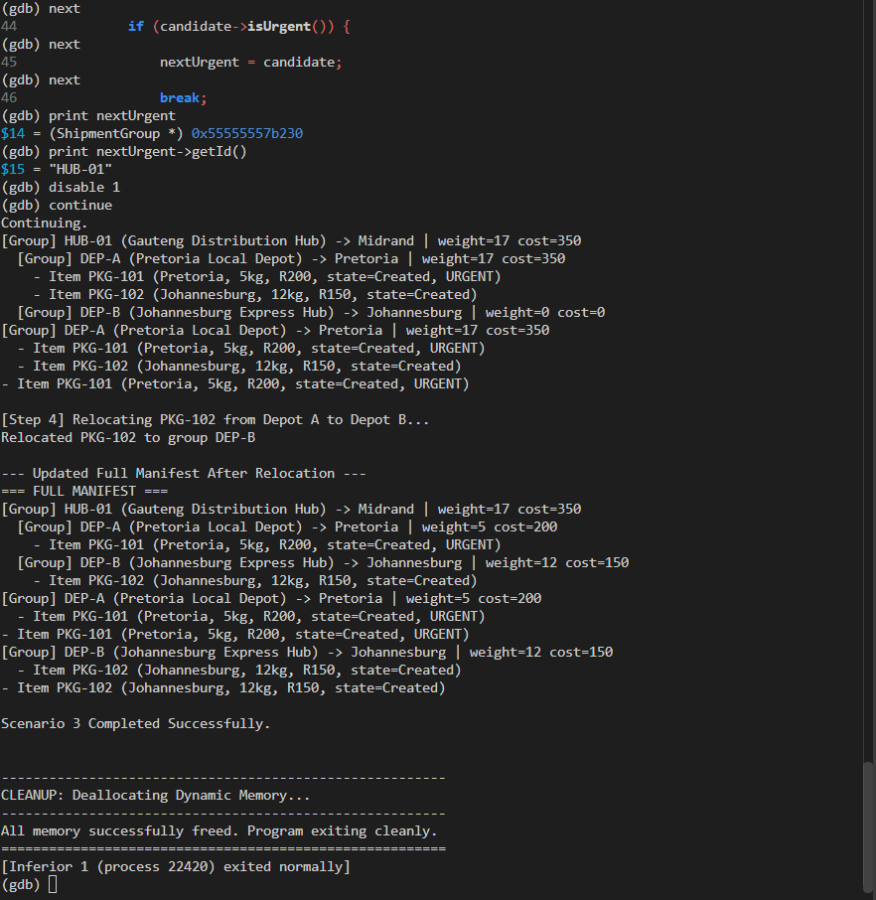

Debugging Evidence for the Bug
A breakpoint was placed in: PriorityIterator::advanceToNextUrgent
The internal iterator contained:
internalIterator->items.size() = 5
The first candidate was:
candidate->getId() = "HUB-01"

GDB's object inspection identified the candidate as a ShipmentGroup:
(ShipmentGroup) {
id = "HUB-01",
name = "Gauteng Distribution Hub",
children = ...
}

The important observation was:
candidate->isUrgent() = true

The reason this returned true was that HUB-01 contained a child shipment that was urgent.
The debugger therefore demonstrated the exact cause of the problem:
HUB-01 is a group
|
+-- contains PKG-101
|
+-- PKG-101 is urgent

Because ShipmentGroup::isUrgent() propagates urgency from its children, the original priority iterator incorrectly treated the group itself as an urgent result.
This was a genuine functional bug rather than a debugger artefact.
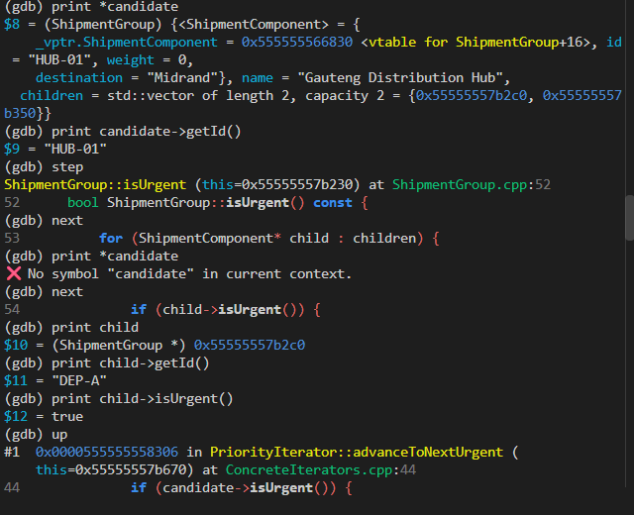

Correction of the Bug
The priority iterator was changed so that it only accepts components that are not ShipmentGroup objects and that are urgent.
The corrected implementation is:
void PriorityIterator::advanceToNextUrgent() {
nextUrgent = nullptr;

while (internalIterator->hasNext()) {
ShipmentComponent* candidate = internalIterator->next();

if (dynamic_cast<ShipmentGroup*>(candidate) == nullptr &&
candidate->isUrgent()) {
nextUrgent = candidate;
break;
}
}
}

The important condition is:
dynamic_cast<ShipmentGroup*>(candidate) == nullptr

A successful dynamic_cast means that the candidate is a ShipmentGroup.
Therefore:
dynamic_cast<ShipmentGroup*>(candidate) == nullptr

means that the candidate is not a ShipmentGroup.
The iterator now performs two checks:
1. Candidate is not a group.
2. Candidate is urgent.

Only when both conditions are satisfied is the candidate returned.
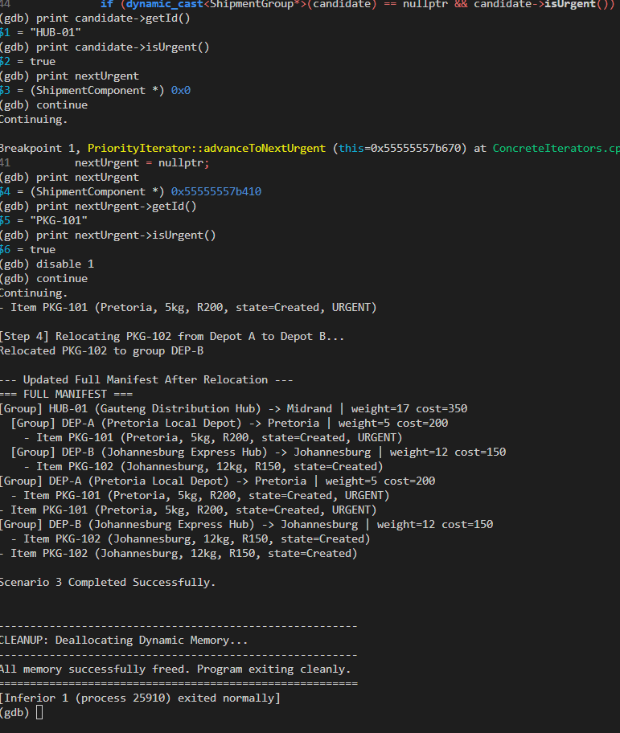

Verification After the Correction
The corrected program was run under GDB again.
At the breakpoint, the first candidate was still:
candidate->getId() = "HUB-01"
candidate->isUrgent() = true
nextUrgent = 0x0

This was important evidence because it demonstrated that HUB-01 was still considered urgent by its own isUrgent() method, but the priority iterator correctly rejected it because it was a group.
The iterator then continued until it reached:
nextUrgent = 0x55555557b410
nextUrgent->getId() = "PKG-101"
nextUrgent->isUrgent() = true

The breakpoint was then disabled and the application continued.
The corrected urgent manifest became:
=== URGENT MANIFEST ===
- Item PKG-101 (Pretoria, 5kg, R200, state=Created, URGENT)

This is the expected result.
The debugging process therefore established the complete chain:
Incorrect output
|
v
PriorityIterator returned groups
|
v
ShipmentGroup::isUrgent() propagated child urgency
|
v
PriorityIterator did not distinguish groups from items
|
v
Added dynamic_cast check
|
v
Only urgent shipment items are returned


Valgrind Memory Investigation
After the bug was corrected, the final application was executed under Valgrind using:
valgrind --leak-check=full --show-leak-kinds=all ./taskforge

The application successfully executed all three scenarios.
The important final Valgrind results were:
HEAP SUMMARY:
in use at exit: 0 bytes in 0 blocks
total heap usage: 98 allocs, 98 frees, 78,902 bytes allocated

All heap blocks were freed -- no leaks are possible

ERROR SUMMARY: 0 errors from 0 contexts

The results can be summarized as follows:
Valgrind Result | Observed Value
Bytes still allocated at exit | 0 bytes
Blocks still allocated at exit | 0 blocks
Total allocations | 98
Total frees | 98
Memory errors | 0
Memory leaks | None reported
The number of allocations and frees also matched:
98 allocs
98 frees

This provides strong evidence that all dynamically allocated objects were eventually released.
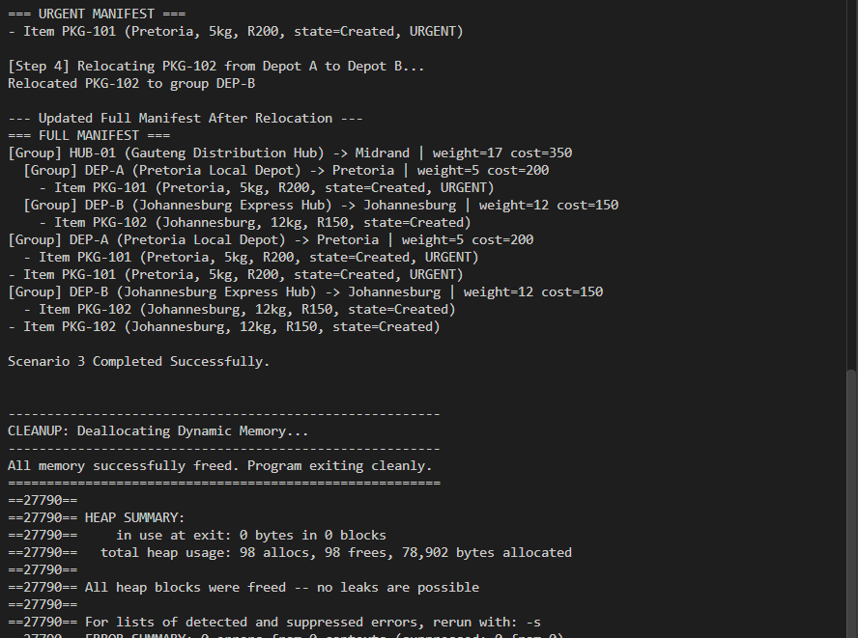

Overall Findings
The investigation produced three significant findings.

Finding 1: State Management
GDB confirmed that the Delivery state machine correctly changes the current state and records the state history.
The observed sequence was:
Created -> PickedUp -> InTransit -> Delivered

The debugger also confirmed that the previous state is deleted when a new state is installed.

Finding 2: Priority Iterator Bug
A genuine bug was identified in the priority iterator.
The iterator incorrectly returned ShipmentGroup objects because ShipmentGroup::isUrgent() returns true when a group contains an urgent child.
GDB was used to prove that:
HUB-01

was a ShipmentGroup, even though:
HUB-01.isUrgent() == true

The iterator was corrected using:
dynamic_cast<ShipmentGroup*>(candidate) == nullptr

After the correction, only:
PKG-101

was returned by the urgent iterator.

Finding 3: Memory Management
Valgrind reported:
0 bytes in use at exit
0 blocks in use at exit
98 allocations
98 frees
0 errors
And All heap blocks were freed -- no leaks are possible

Therefore, the final application did not leave dynamically allocated memory unreleased.

Conclusion
The Taskforge application was successfully investigated using both GDB and Valgrind.
GDB provided detailed runtime evidence of object construction, state transitions and cascading object destruction. The investigation demonstrated how ShipmentGroup, ShipmentItem, Delivery and DeliveryState objects are related and how ownership is managed during program execution.
A genuine functional bug was identified in PriorityIterator. The original implementation treated urgent groups as urgent shipment results because ShipmentGroup::isUrgent() propagates urgency from its children. GDB was used to identify the exact object causing the incorrect output and to confirm that the candidate was a ShipmentGroup.
The bug was corrected by modifying the iterator to reject ShipmentGroup objects and only return urgent shipment items. The corrected program produced the expected urgent manifest containing only PKG-101.
Finally, Valgrind was used to analyse the completed application. The final run reported:
in use at exit: 0 bytes in 0 blocks
98 allocs, 98 frees
All heap blocks were freed -- no leaks are possible
ERROR SUMMARY: 0 errors from 0 contexts

These results provide evidence that the final Taskforge implementation executes correctly, that the investigated bug has been resolved, and that the application's dynamically allocated memory is properly released.

